Ellipse

Definition
# Source: AI Source: Provided by: [Data Path: Persons Table -> ID Column: 1, Name_En Column: Motasem Essam] -> From: [ChatGPT] on [7/25/2026]
An ellipse is a closed plane curve in which the sum of the distances from every point on the curve to two fixed points is constant.
The two fixed points are called the foci.
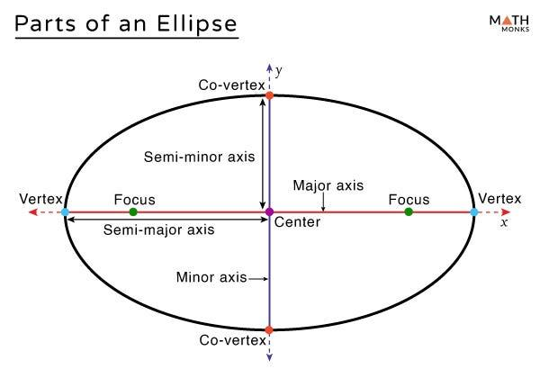
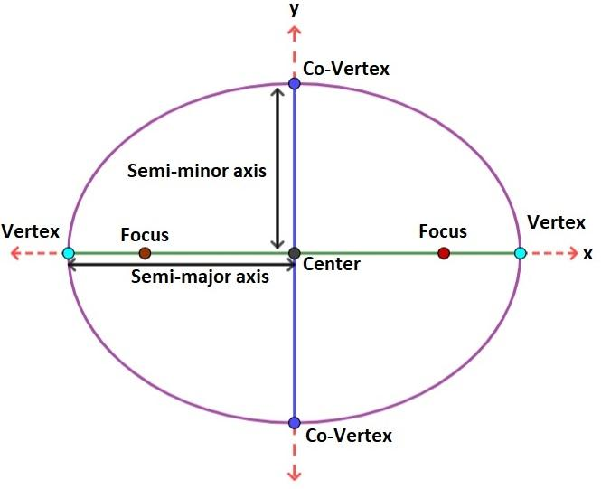
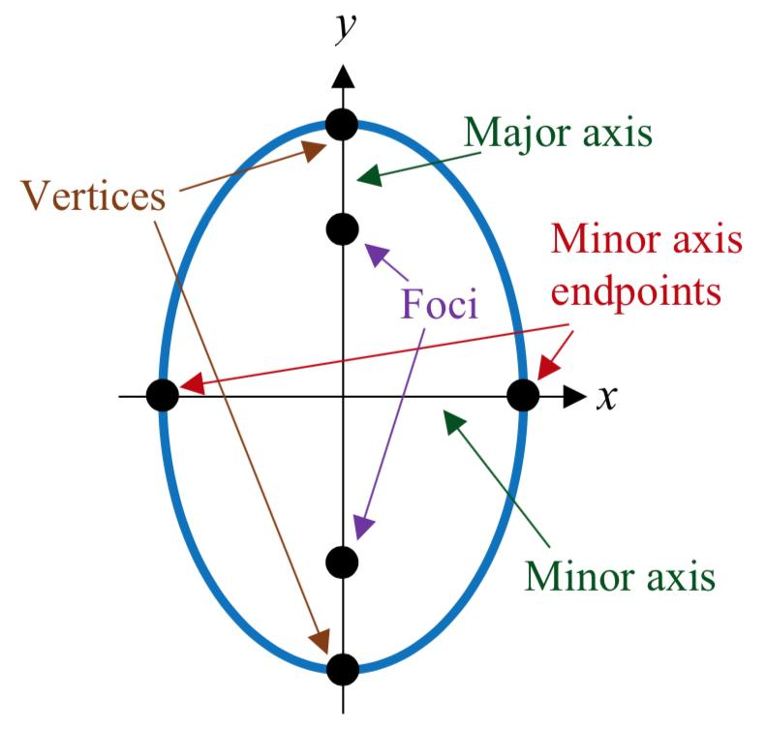
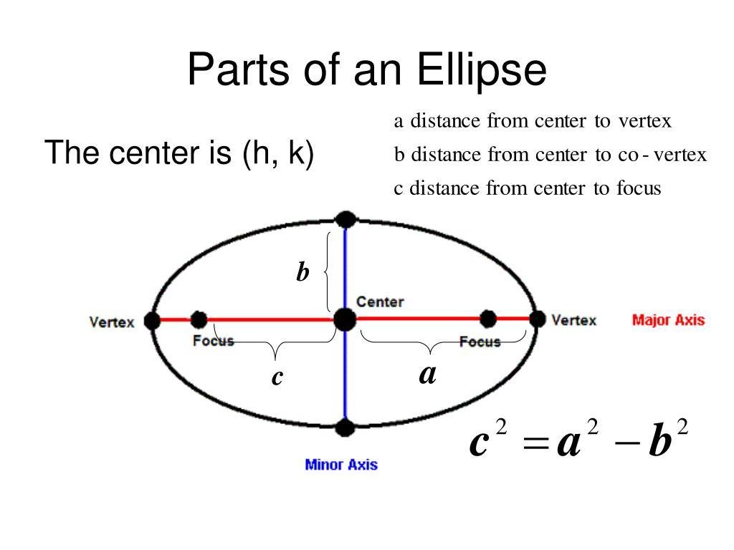
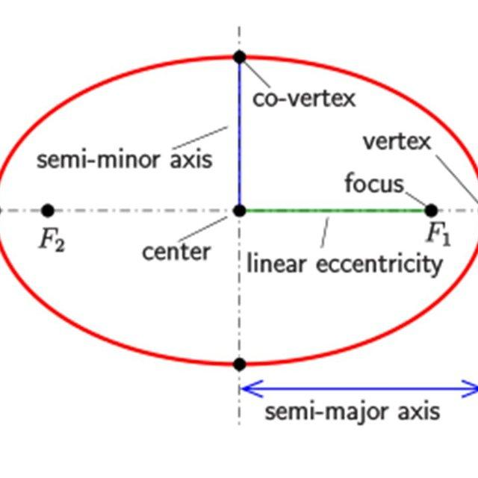
For any point $P$on an ellipse with foci $F_{1}$and $F_{2}$:
$$\boxed{PF_{1}+PF_{2}=2a}$$
where $a$is the semi-major axis.

Fundamental Elements
# Source: AI Source: Provided by: [Data Path: Persons Table -> ID Column: 1, Name_En Column: Motasem Essam] -> From: [ChatGPT] on [7/25/2026]
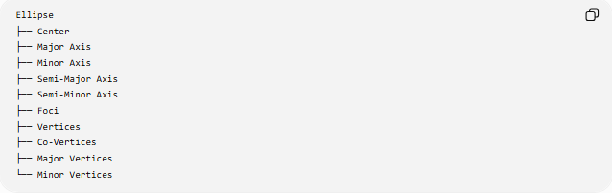
Ellipse
├── Center
├── Major Axis
├── Minor Axis
├── Semi-Major Axis
├── Semi-Minor Axis
├── Foci
├── Vertices
├── Co-Vertices
├── Major Vertices
└── Minor Vertices
1. Center
The center is the midpoint of both the major axis and minor axis.
It is commonly represented by:
$$\left(h , k\right)$$
2. Major Axis
The major axis is the longest diameter of the ellipse.
Its length is:
$$\boxed{2a}$$
3. Minor Axis
The minor axis is the shortest diameter.
Its length is:
$$\boxed{2b}$$
where normally:
$$a≥b$$
4. Semi-Major Axis
The semi-major axis is half the major axis:
$$\boxed{a=\frac{\text{major axis}}{2}}$$
5. Semi-Minor Axis
The semi-minor axis is half the minor axis:
$$\boxed{b=\frac{\text{minor axis}}{2}}$$
6. Foci
The foci are two fixed points inside the ellipse.
For a horizontal ellipse centered at $\left(h , k\right)$:
$$F_{1}=\left(h , -ck\right) \\ F_{2}=\left(h , +ck\right)$$
where
$$\boxed{c^{2}=a^{2}-b^{2}}$$

Standard Equations

Horizontal Ellipse
# Source: AI Source: Provided by: [Data Path: Persons Table -> ID Column: 1, Name_En Column: Motasem Essam] -> From: [ChatGPT] on [7/25/2026]
If the major axis is horizontal:
$$\boxed{\frac{{\left(x-h\right)}^{2}}{a^{2}}+\frac{{\left(y-k\right)}^{2}}{b^{2}}=1}$$
where:
$$a>b$$
The vertices are:
$$\left(h , -ak\right), \left(h , +ak\right)$$
The co-vertices are:
$$\left(h , k-b\right), \left(h , k+b\right)$$
The foci are:
$$\left(h , -ck\right), \left(h , +ck\right)$$

Vertical Ellipse
# Source: AI Source: Provided by: [Data Path: Persons Table -> ID Column: 1, Name_En Column: Motasem Essam] -> From: [ChatGPT] on [7/25/2026]
If the major axis is vertical:
$$\boxed{\frac{{\left(x-h\right)}^{2}}{b^{2}}+\frac{{\left(y-k\right)}^{2}}{a^{2}}=1}$$
The vertices are:
$$\left(h , k-a\right), \left(h , k+a\right)$$
The co-vertices are:
$$\left(h , -bk\right), \left(h , +bk\right)$$
The foci are:
$$\left(h , k-c\right), \left(h , k+c\right)$$
with:
$$\boxed{c^{2}=a^{2}-b^{2}}$$

Eccentricity
# Source: AI Source: Provided by: [Data Path: Persons Table -> ID Column: 1, Name_En Column: Motasem Essam] -> From: [ChatGPT] on [7/25/2026]
The eccentricity measures how elongated an ellipse is.
$$\boxed{e=\frac{c}{a}}$$
For an ellipse:
$$\boxed{0<e<1}$$
Using $c^{2}=a^{2}-b^{2}$:
$$\boxed{e=\sqrt{1-\frac{b^{2}}{a^{2}}}}$$
Meaning of Eccentricity
- $e$close to $0$→ ellipse is close to a circle.
- Larger $e$→ ellipse is more elongated.
- $e=0$→ circle, as the limiting special case.
- An ellipse never has $e≥1$.
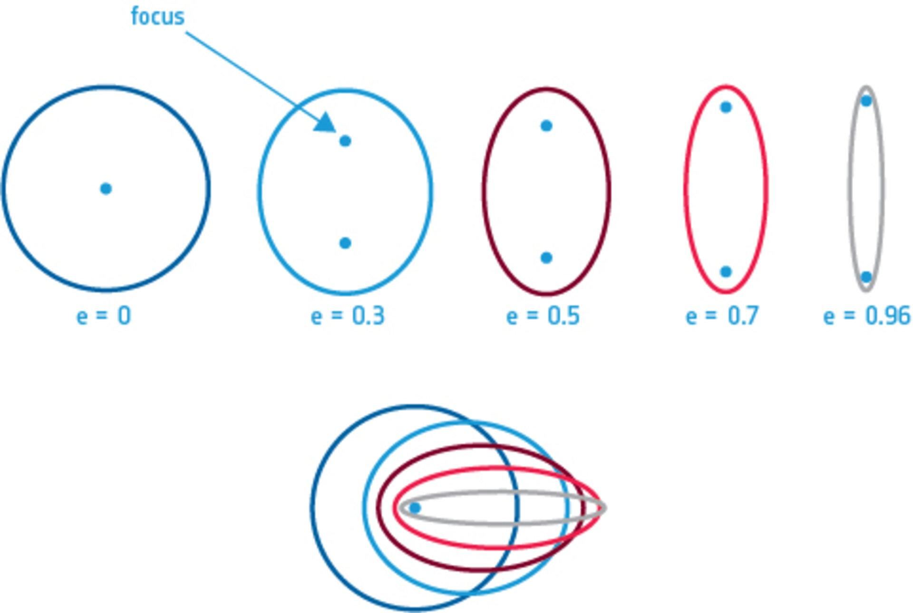
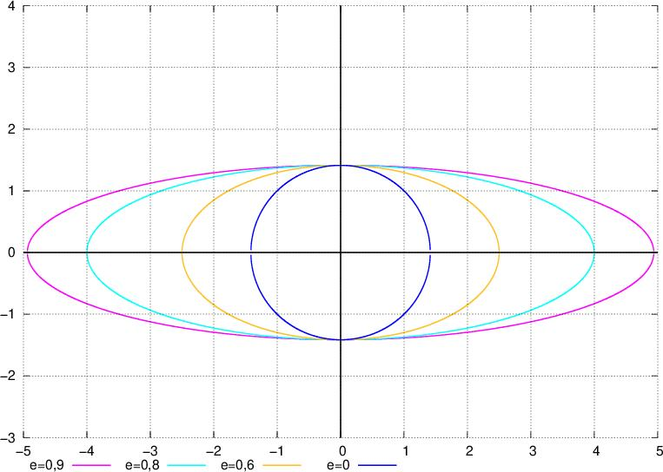
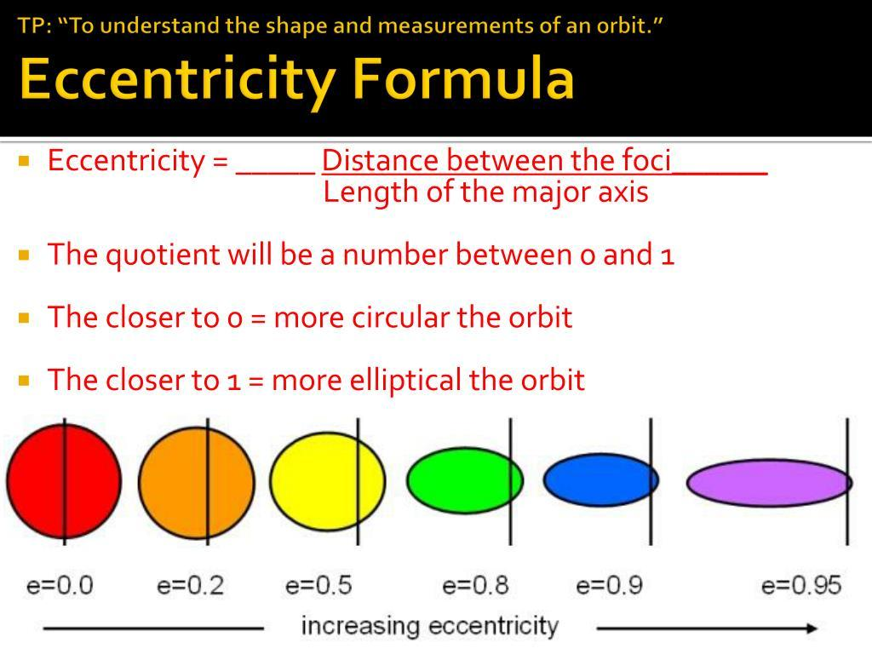
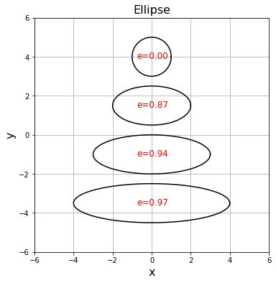
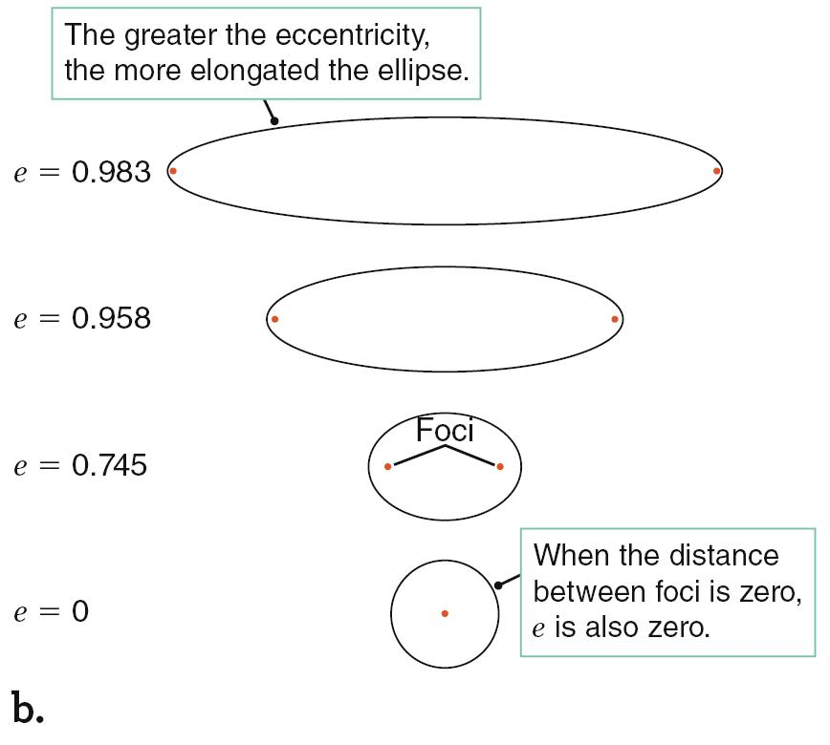
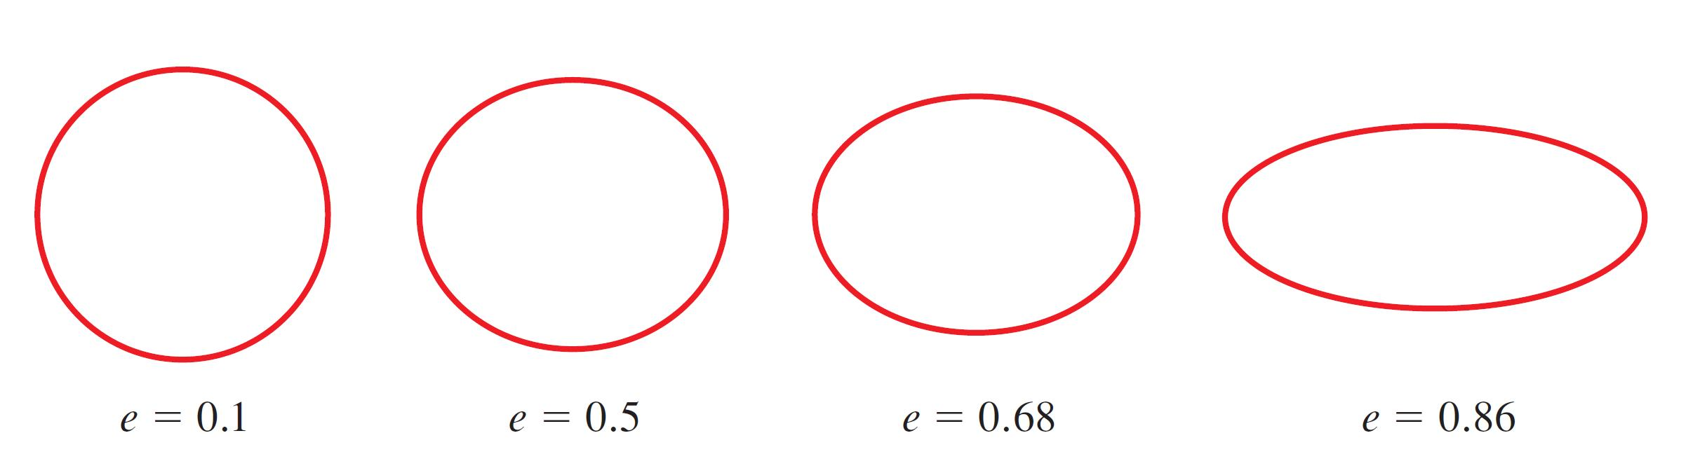

Area
# Source: AI Source: Provided by: [Data Path: Persons Table -> ID Column: 1, Name_En Column: Motasem Essam] -> From: [ChatGPT] on [7/25/2026]
The area enclosed by an ellipse is:
$$\boxed{A=πab}$$
where:
- $a$= semi-major axis
- $b$= semi-minor axis.
Example
If:
$$a=6, b=4$$
then:
$$A=π\left(6\right)\left(4\right) \\ \boxed{A=24π}$$
approximately:
$$A≈75.40$$

Perimeter
# Source: AI Source: Provided by: [Data Path: Persons Table -> ID Column: 1, Name_En Column: Motasem Essam] -> From: [ChatGPT] on [7/25/2026]
Unlike a circle, an ellipse does not have a simple exact elementary formula for its perimeter.
A commonly used approximation is:
$$\boxed{P≈π\left[3\left(a+b\right)-\sqrt{\left(3a+b\right)\left(a+3b\right)}\right]}$$
This is an approximation rather than an exact elementary formula.

Main Properties
# Source: AI Source: Provided by: [Data Path: Persons Table -> ID Column: 1, Name_En Column: Motasem Essam] -> From: [ChatGPT] on [7/25/2026]
- An ellipse is a closed curve.
- It has two foci.
- The sum of distances to the two foci is constant.
- It has one major axis and one minor axis.
- The major axis is perpendicular to the minor axis.
- The center bisects both axes.
- The major axis has length $2a$.
- The minor axis has length $2b$.
- The distance from the center to either focus is $c$.
- They satisfy:
$$\boxed{a^{2}=b^{2}+c^{2}}$$
- Its eccentricity satisfies:
$$\boxed{0≤e<1}$$
with $e=0$corresponding to the circular special case.
- An ellipse has two perpendicular lines of reflection symmetry.
- It has rotational symmetry of order $2$.

Circle as a Special Ellipse
# Source: AI Source: Provided by: [Data Path: Persons Table -> ID Column: 1, Name_En Column: Motasem Essam] -> From: [ChatGPT] on [7/25/2026]
A circle can be considered a special ellipse where:
$$a=b$$
Therefore:
$$c^{2}=a^{2}-b^{2}=0$$
so:
$$c=0$$
and consequently:
$$e=\frac{c}{a}=0$$
Thus:
$$\boxed{\text{Circle}=\text{Ellipse with }e=0}$$

Reflection Property
# Source: AI Source: Provided by: [Data Path: Persons Table -> ID Column: 1, Name_En Column: Motasem Essam] -> From: [ChatGPT] on [7/25/2026]
An important property of an ellipse is its reflection property.
A ray directed toward one focus and reflected from the ellipse is reflected toward the other focus.
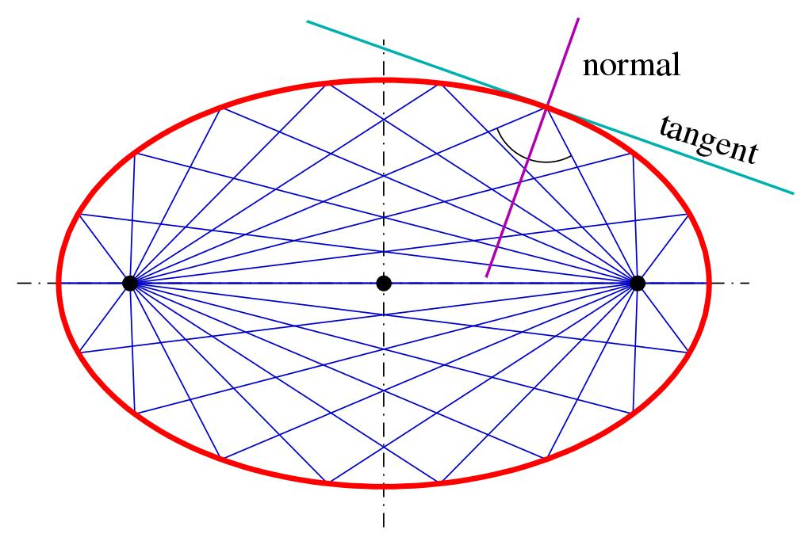
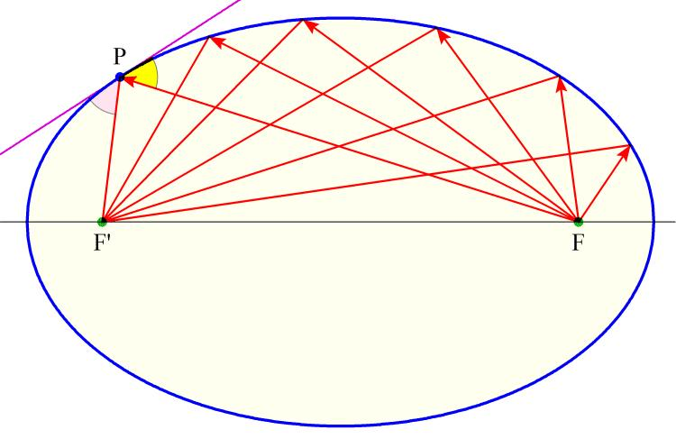
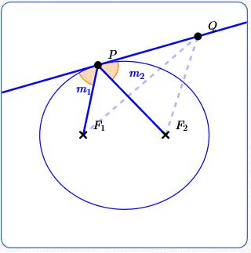
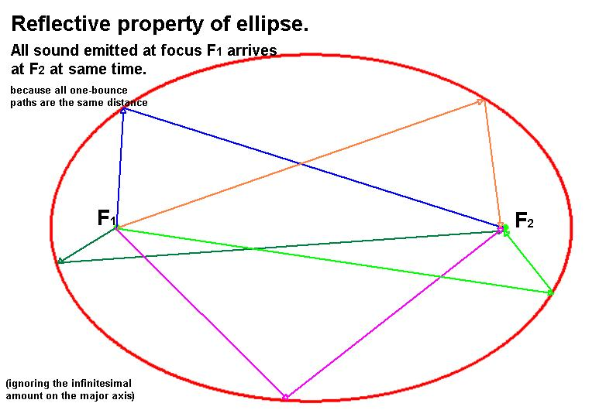
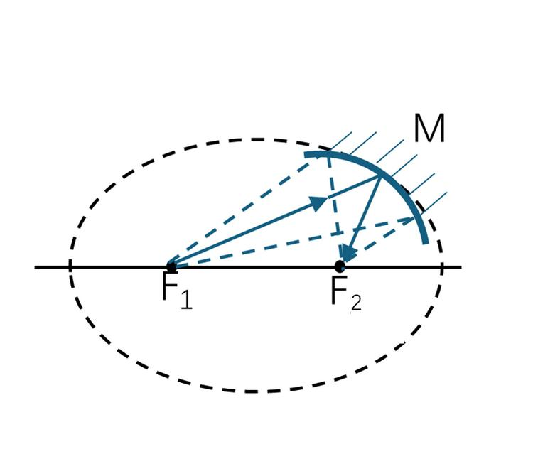
This property is used in certain optical and acoustic applications.

Types of Ellipses
# Source: AI Source: Provided by: [Data Path: Persons Table -> ID Column: 1, Name_En Column: Motasem Essam] -> From: [ChatGPT] on [7/25/2026]
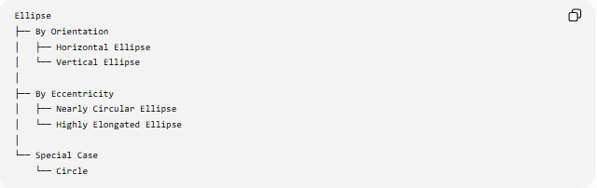
Ellipse
├── By Orientation
│ ├── Horizontal Ellipse
│ └── Vertical Ellipse
│
├── By Eccentricity
│ ├── Nearly Circular Ellipse
│ └── Highly Elongated Ellipse
│
└── Special Case
└── Circle
The orientation classification refers to whether the major axis is horizontal or vertical.

Example: Finding the Foci
# Source: AI Source: Provided by: [Data Path: Persons Table -> ID Column: 1, Name_En Column: Motasem Essam] -> From: [ChatGPT] on [7/25/2026]
Consider:
$$\frac{x^{2}}{25}+\frac{y^{2}}{9}=1$$
Here:
$$a^{2}=25 \\ b^{2}=9$$
Therefore:
$$a=5, b=3$$
Using:
$$c^{2}=a^{2}-b^{2} \\ c^{2}=25-9=16 \\ c=4$$
The ellipse is horizontal, so its foci are:
$$\boxed{\left(- , 40\right)\text{ and }\left(4 , 0\right)}$$
Its eccentricity is:
$$e=\frac{4}{5} \\ \boxed{e=0.8}$$

Relationship with Conic Sections
# Source: AI Source: Provided by: [Data Path: Persons Table -> ID Column: 1, Name_En Column: Motasem Essam] -> From: [ChatGPT] on [7/25/2026]
An ellipse is one of the four principal non-degenerate conic sections.
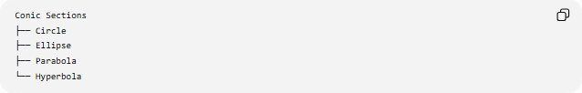
Conic Sections
├── Circle
├── Ellipse
├── Parabola
└── Hyperbola
Its eccentricity distinguishes it from the other conics:
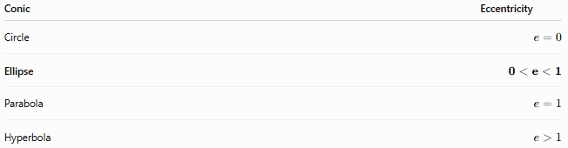
Conic | Eccentricity
Circle | $$e=0$$
Ellipse | $$0<e<1$$
Parabola | $$e=1$$
Hyperbola | $$e>1$$

Real-World Applications
# Source: AI Source: Provided by: [Data Path: Persons Table -> ID Column: 1, Name_En Column: Motasem Essam] -> From: [ChatGPT] on [7/25/2026]
Ellipses occur in:
- Planetary orbits
- Satellite orbits
- Astronomy
- Optical systems
- Reflectors
- Acoustic rooms
- Architecture
- Engineering
- Mechanical design
- Computer graphics
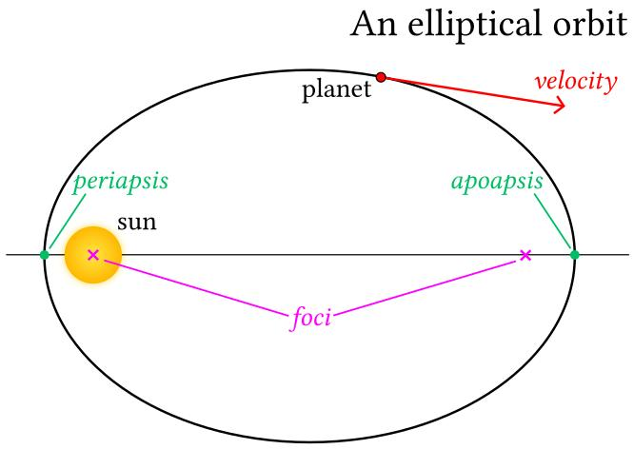
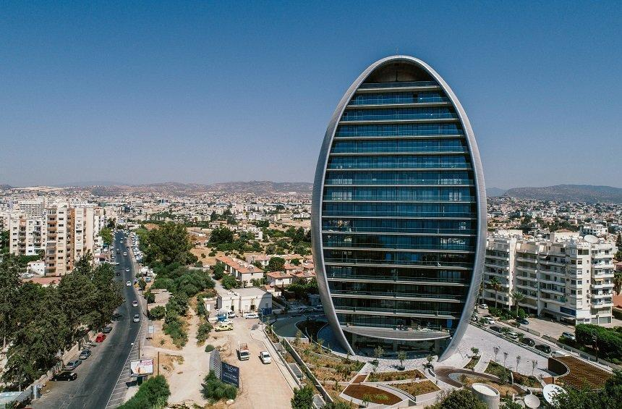
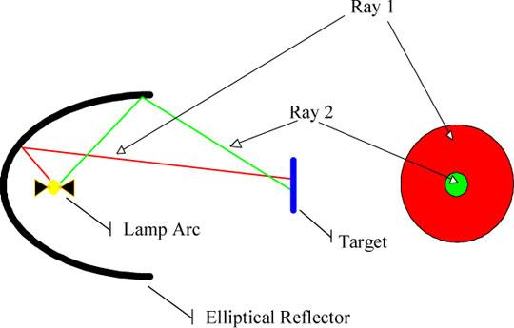
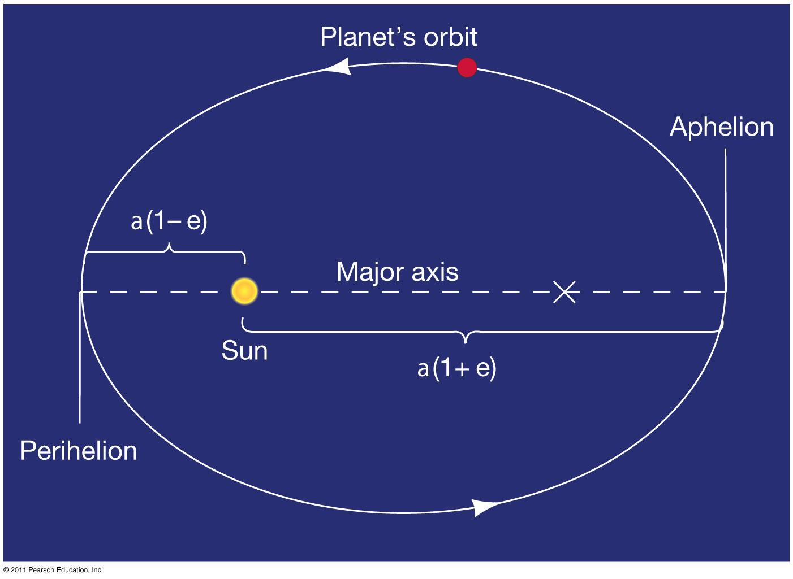
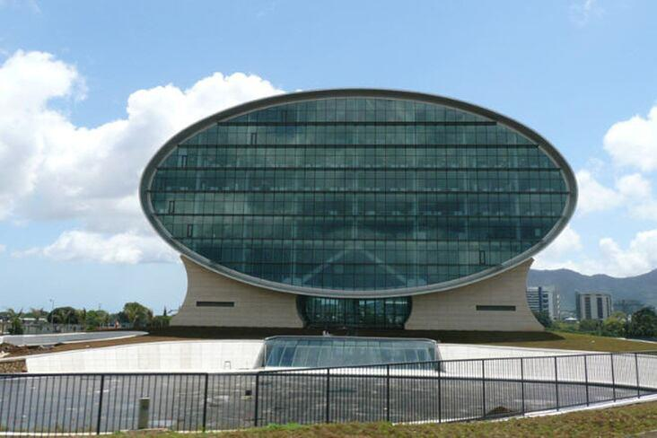
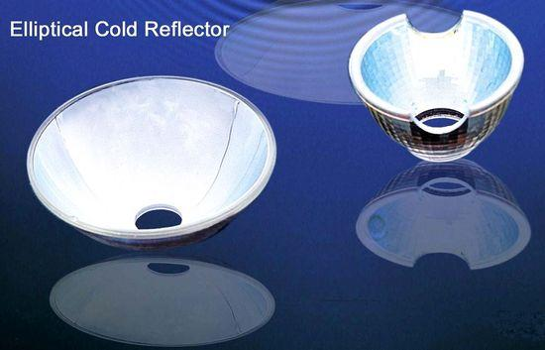

Key Formulas
# Source: AI Source: Provided by: [Data Path: Persons Table -> ID Column: 1, Name_En Column: Motasem Essam] -> From: [ChatGPT] on [7/25/2026]
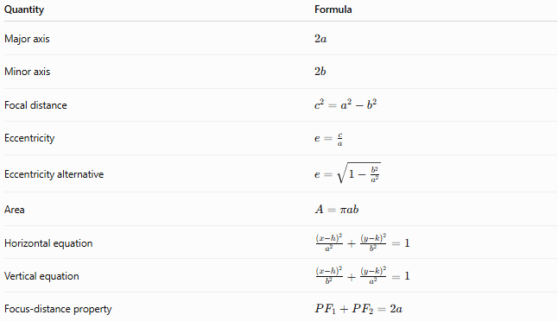
Quantity | Formula
Major axis | $$2a$$
Minor axis | $$2b$$
Focal distance | $$c^{2}=a^{2}-b^{2}$$
Eccentricity | $$e=\frac{c}{a}$$
Eccentricity alternative | $$e=\sqrt{1-\frac{b^{2}}{a^{2}}}$$
Area | $$A=πab$$
Horizontal equation | $$\frac{{\left(x-h\right)}^{2}}{a^{2}}+\frac{{\left(y-k\right)}^{2}}{b^{2}}=1$$
Vertical equation | $$\frac{{\left(x-h\right)}^{2}}{b^{2}}+\frac{{\left(y-k\right)}^{2}}{a^{2}}=1$$
Focus-distance property | $$PF_{1}+PF_{2}=2a$$

Key Points
# Source: AI Source: Provided by: [Data Path: Persons Table -> ID Column: 1, Name_En Column: Motasem Essam] -> From: [ChatGPT] on [7/25/2026]
- An ellipse is a closed conic section.
- It has two foci.
- The sum of distances from any point on the ellipse to the two foci is constant.
- $a$is the semi-major axis.
- $b$is the semi-minor axis.
- $c$is the center-to-focus distance.
- $a^{2}=b^{2}+c^{2}$.
- Its eccentricity satisfies $0<e<1$for a non-circular ellipse.
- Its area is $πab$.
- A circle is the special case $a=b$and $e=0$.

Conclusion
# Source: AI Source: Provided by: [Data Path: Persons Table -> ID Column: 1, Name_En Column: Motasem Essam] -> From: [ChatGPT] on [7/25/2026]
An ellipse is a closed conic defined by a constant sum of distances to two foci. Its geometry is primarily determined by the semi-major axis $a$, semi-minor axis $b$, focal distance $c$, and eccentricity $e$:
$$\boxed{a^{2}=b^{2}+c^{2}} \\ \boxed{e=\frac{c}{a}} \\ \boxed{A=πab}$$

